DAY 2 — PUBLIC IP vs PRIVATE IP ADDRESSING
INTRODUCTION
Every device connected to a network requires an IP address for communication.
🌐 What is an IP Address?
✅ Definition
An IP Address (Internet Protocol Address) is a unique numerical address assigned to a device in a network for communication.
It helps devices:
- Identify each other
- Send data
- Receive data
- Communicate over networks and the internet

🧠 Simple Understanding
Just like:
📬 House address helps identify your home
Similarly:
🌐 IP address helps identify a device on a network.

💻 Example IP Address
IPv4 Example: 192.168.1.1
IPv6 Example: 2401:4900:97c2:aa1e::abcd

🎯 Main Purpose of IP Address
IP addresses are used for:
✅ Device identification
✅ Communication between devices
✅ Internet access
✅ Data routing
✅ Network management

🌍 Types of IP Addresses
Type | Purpose
Private IP | Used inside local networks
Public IP | Used on internet
IPv4 | 32-bit address
IPv6 | 128-bit address

IP addresses are categorized into:
- Public IP Address
- Private IP Address
Understanding these concepts is important in networking, cybersecurity, and Identity & Access Management (IAM).

What is a Public IP Address?
A Public IP Address is an IP address visible on the internet.
It is assigned by the Internet Service Provider (ISP).
Public IPs allow communication between devices over the internet.
Example:
106.192.36.233
Characteristics:
- Globally unique
- Internet-visible
- Assigned by ISP
- Used for internet communication

What is a Private IP Address?
A Private IP Address is used inside local/private networks.
Private IPs are not directly accessible on the internet.
Example:
10.221.64.26
Characteristics:
- Used internally
- Assigned by router
- More secure internally
- Reusable in different organizations

Private IP Ranges
10.0.0.0 – 10.255.255.255
172.16.0.0 – 172.31.255.255
192.168.0.0 – 192.168.255.255

Difference Between Public and Private IP
Public IP | Private IP
Visible on internet | Used inside local network
Assigned by ISP | Assigned by router
Globally unique | Local use only
Used for internet communication | Used for internal communication

What is NAT?
NAT stands for Network Address Translation.
NAT converts:
Private IP → Public IP
Example:
10.221.64.26
↓
106.192.36.233
NAT allows multiple devices inside a network to share one public IP address.

Why NAT is Important
NAT helps:
- Save IPv4 addresses
- Improve security
- Hide internal IP addresses
- Allow internet access for private devices

What is ISP?
ISP stands for Internet Service Provider.
Examples:
- Airtel
- Jio
- BSNL
- ACT
ISP assigns public IP addresses to users.

Internet Communication Flow
Laptop → Router/Gateway → Public IP → Internet
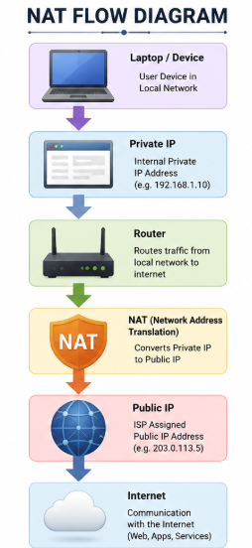

IAM Security Connection
IAM systems use IP addresses for:
- Login monitoring
- Geo-location tracking
- Conditional access
- VPN restrictions
- Suspicious login detection
- MFA triggering
Example:
If login occurs from another country, IAM may trigger MFA or block access.

Commands Practiced
ipconfig
ping google.com
nslookup google.com

Key Learning Outcome
Through this topic, I learned:
- Difference between public and private IP addresses
- NAT functionality
- ISP role in networking
- Internet communication flow
- Importance of IP addresses in IAM security

